**Ideation Phase**

**Define the Problem Statements**

|  |  |
| --- | --- |
| Date | 27 June 2025 |
| Team ID | LTVIP2025TMID28869 |
| Project Name | Educational Organisation Using Servicenow |
| Maximum Marks | 2 Marks |

**Customer Problem Statement Template:** A Customer Problem Statement helps you understand your customer's challenges from their perspective. This template guides teams in identifying what matters most to users, so they can create meaningful solutions. It helps clarify customer goals, barriers, reasons behind those barriers, and the emotions they evoked.

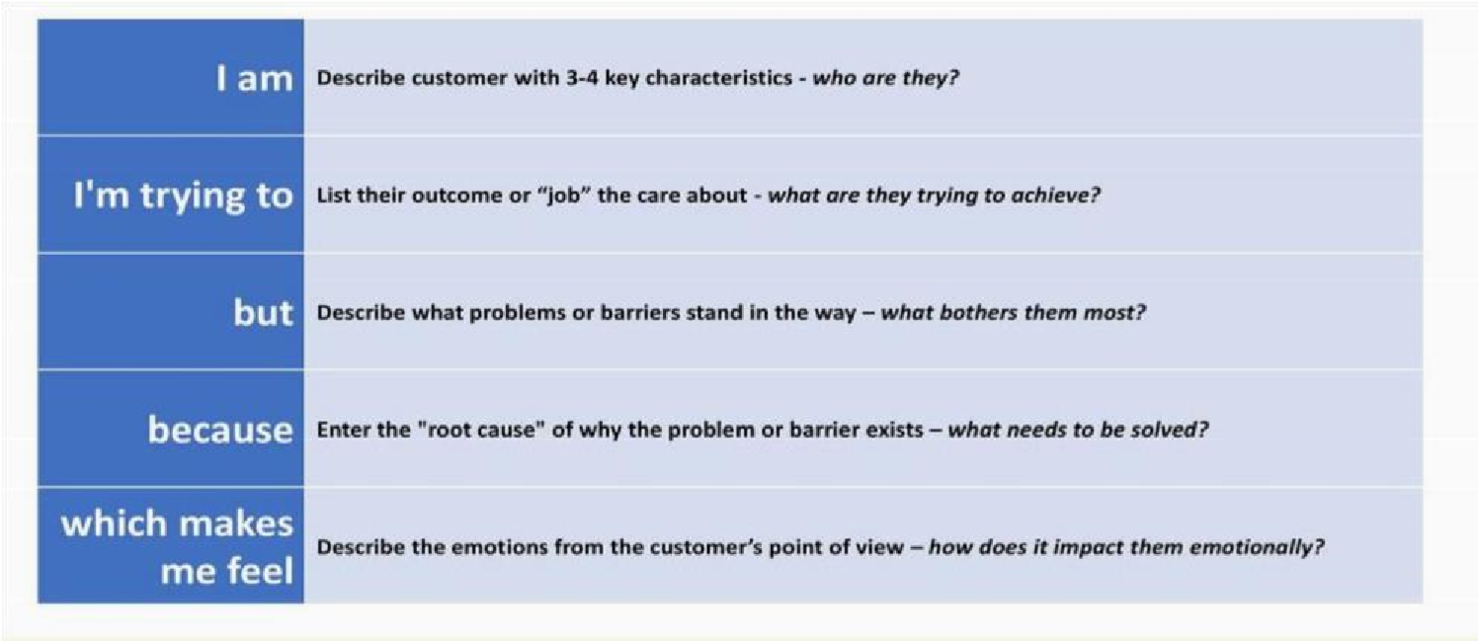

Reference: [https://miro.com/templates/customer-problem-statement/ **E**](https://miro.com/templates/customer-problem-statement/)**xample:**

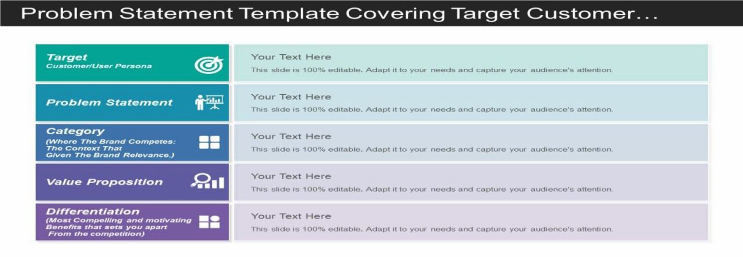

|  |  |  |  |  |  |
| --- | --- | --- | --- | --- | --- |
| **Problem**  **Statement (PS)** | **I am**  **(Customer)** | **I’m trying to** | **But** | **Because** | **Which makes me feel** |
| PS-1 | a college student | find affordable textbooks | they are too expensive | most books are only available at full price | stressed and frustrated |
| PS-2 | a working parent | order healthy meals for my  kids | the options are limited online | most meal services focus on adult meals | worried and disappointed |